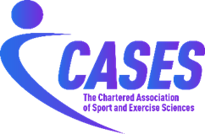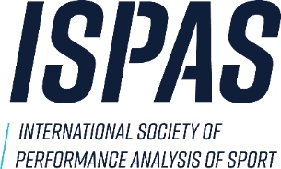
Commitment to Partnership between
THE INTERNATIONAL SOCIETY OF PERFORMANCE ANALYSIS OF SPORT (ISPAS)

and

THE CHARTERED ASSOCIATION OF SPORT AND EXERCISE SCIENCES (CASES)

- Purpose:

The purpose of this partnership is to develop a long-term co-operation between both organisations, specifically to develop the area of sports performance analysis within CASES and ISPAS.

- Background

- ISPAS is an international society working to provide support for sport performance analysts at all stages of their career, whether in academic or applied settings.

- CASES is the professional body for sport and exercise sciences in the United Kingdom. CASES’ mission is to promote excellence in sport and exercise sciences through evidence-based practice.

- Collaboration

In partnership. the two organisations agree to -

- Develop performance analysis (ISPAS) representation within relevant CASES governance structure.
- Grow the CASES Performance Analysis Special Interest Group (PA SIG), sharing outputs with ISPAS.
- Explore the possibilities of developing a Sport Performance Analysis Division within CASES.
- Identify opportunities to collaborate through Publications, CPD, Webinars, Conferences, Meetings etc.
- Support and recognise ISPAS accreditation frameworks for performance analysts and to align, where possible, with CASES accreditations/recognition
- Support Equity, Diversity and Inclusion projects within Sport Performance Analysis
- Both organisations to work together to achieve the above aims and to reduce any barriers to progress, where possible
- To seek out other mutually beneficial activities creatively and proactively including, but limited to, joint press releases, public engagement activities and influencing policy makers.

The terms of co-operation for each specific activity implemented under this Commitment to Partnership shall be mutually discussed and agreed upon in writing by both parties prior to the initiation of that activity and will be the subject of separate agreements. This shall include ownership of copyright and other intellectual property generated by mutual activities.

This Commitment to Partnership is between the two signatory organisations and does not impose requirements on the individual members of each organisation.

- Duration and Review

This Commitment to Partnership becomes effective from the date that the representatives of the participating parties sign this agreement below. The intention is for the agreement to continue for three years, with an annual review. At the end of the term, this Commitment to Partnership may be extended by the mutual written agreement of both organisations.

This Commitment to Partnership may be revised through the mutual agreement of both organisations and may be terminated by either party upon giving six months’ written notice signed by the recognised Executive Officer of the notifying party.

- Other

Any use of the names “ISPAS”, “International Society of Performance Analysis of Sport”, “The Chartered Association of Sport and Exercise Sciences” or “CASES”, including logos and any other intellectual property exclusively owned by either organisation, and relating in any way to the activities described in this Commitment to Partnership, shall be subject to prior written approval.

The administration of this Commitment to Partnership will be the responsibility of the relevant executive management bodies of the participating parties.

In witness to this agreement, the following individuals append their signatures:

For ISPAS  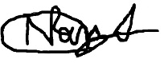  Name: Dr Nimai Parmar  Post: ISPAS Director  Date: 5 November 2024 | For CASES  Name: Ian Wilson  Post: Executive Director  Date: 5 November 2024

